# Release Information

|  |  |
| --- | --- |
| *Release* | *1* |
| *Leader* | *Mitch Vance* |
| *Git Repo* | *https://vancemi@atlas.ion.uwplatt.edu/bitbucket/scm/ise/1-nullreferenceexception.git* |

This release is the initial release of our program. The main purpose of this release is to have the basic functionality of the program so that we have a good base to work off of for future iterations.

# Progress

|  |  |  |  |
| --- | --- | --- | --- |
| **Stories and spike solutions worked on during this release** | | | |
| **Story, Spike** | **Description** | **% Impl.** | **Notes, plan for completion** |
| *NRE-5* | *Client should send message and receive* | *100* | *completed* |
| *NRE-10* | *Client prompts for name to use* | *90* | *Completed, but string is not validated and does not use service to talk to server.* |
| *NRE-22* | *Server should use observer pattern for communicating to clients.* | *100* | *Completed.* |
| *NRE-29* | *Connected to the server and prompt name* | *100* | *Completed.* |
| *Spike0* | *Mock UI* | *100* | *Completed.* |
| *Spike1* | *Investigate plausible server architecture.* | *100* | *Completed.* |

|  |  |  |
| --- | --- | --- |
| **Accomplishments by engineer** | | |
| **Team Member** | **Total Time (hrs)** | **Stories, Spikes implemented** |
| *Austin* | *8h52m* | *NRE-5 (w/Mitch)*  *NRE-10 (w/Ryan)* |
| *Liam* | *8h40m* | *NRE-10 (w/ Ryan)*  *NRE-29 (w/Ryan)* |
| *Mitch* | *11h* | *NRE-5 (w/Austin)* |
| *Ryan* | *13h* | *NRE-10 (Austin)*  *NRE-22 (w/Liam)*  *NRE-29 (w/Liam)*  *Spike0*  *Spike1* |
| TEAM TOTAL | ***41.5h*** |  |

|  |  |
| --- | --- |
| **Document updates** | |
| **Document** | **Changes** |
| *README.md* | *Added README to git repo.* |
|  |  |

# Issues

Document anything that is not decided yet and needs to be resolved at some point.

|  |  |  |  |  |
| --- | --- | --- | --- | --- |
| **Issue Number** | **Discovery**  **Date** | **Resolution**  **Date (Est.–Act.)** | **Responsible Person** | **Description (Prob / Resolution)** |
| 1 | 3/2 | 3/11-2/18 | Austin | Username prompt does not validate input.  Will need to validate against bad input. |
| 2 | 3/7 | 3/11-3/15 | Mitch | Username prompt does not use the MessageService to send a message to server. Need to updated code to go through designated methods. |
|  |  |  |  |  |
|  |  |  |  |  |

# Screen Shots

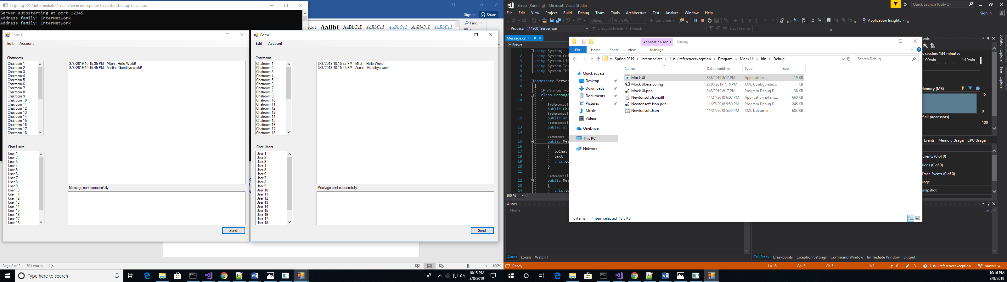

*This demonstrates that a message sent from client(s) are sent to the server and are then return to all clients and displayed in the message area.*